**Major Project**

**Batch No :** B9

**Roll No’s :** 20241A04B4,20241A0480,20241A04B6

**Project Title :** Advancing Diabetic Foot Ulcer Detection: A Proposal for

Multi- Class Classification

**Project Description:**

Diabetic foot ulcers (DFUs) are chronic wounds that commonly occur in individuals with diabetes. They result from reduced blood flow and nerve damage, making the feet vulnerable to injuries and slow healing. DFUs can lead to severe complications if left untreated, emphasizing the need for early detection and specialized care in diabetes management. Timely intervention and proper wound care are essential to prevent complications and improve the quality of life for individuals with DFUs**.**

**Existing Approach:**

Previous research in DFU detection has primarily relied on binary classification techniques, including Support Vector Machines (SVM), Convolutional Neural Networks (CNN), and EfficientNet. While these techniques have yielded valuable insights, they inherently limit the characterization of DFUs to binary outcomes, overlooking the finer details that are crucial for comprehensive diagnosis and treatment planning. However, DFUs are complex in nature, exhibiting diverse characteristics such as ulcer type, severity, and location, which necessitates a more nuanced approach to classification.

**Proposed Techniques:**

This proposal addresses the limitations of binary classification and presents a comprehensive strategy to transition from binary to multi-class DFU classification. We recognize that DFUs, in their various stages and manifestations, demand a finer-grained analysis for accurate diagnosis and treatment planning. Therefore, this proposal introduces five key techniques to overcome binary classification constraints:

**1.Multi-Label Classification:** Implementing multi-label classification to assign multiple labels (classes) to each DFU image, enabling a detailed characterization of ulcer features.

**2.Customized CNN Architectures:** Designing customized Convolutional Neural Network (CNN) architectures tailored to multi-class DFU classification, accommodating the intricacies of the condition.

**3.Fine-Grained Image Analysis:** Applying fine-grained image analysis techniques, such as object detection and segmentation, to identify specific regions or components within DFU images, enhancing multi-class differentiation.

**4.Hierarchical Classification:** Implementing a hierarchical classification approach to categorize DFUs into broader categories and then subdivide them into finer classes, simplifying the multi-class problem.

**5.Ensemble of Neural Networks:** Creating an ensemble of specialized neural networks, each focusing on different aspects of DFU classification and combining their predictions to achieve robust multi-class results.

Different grades of foot ulcers

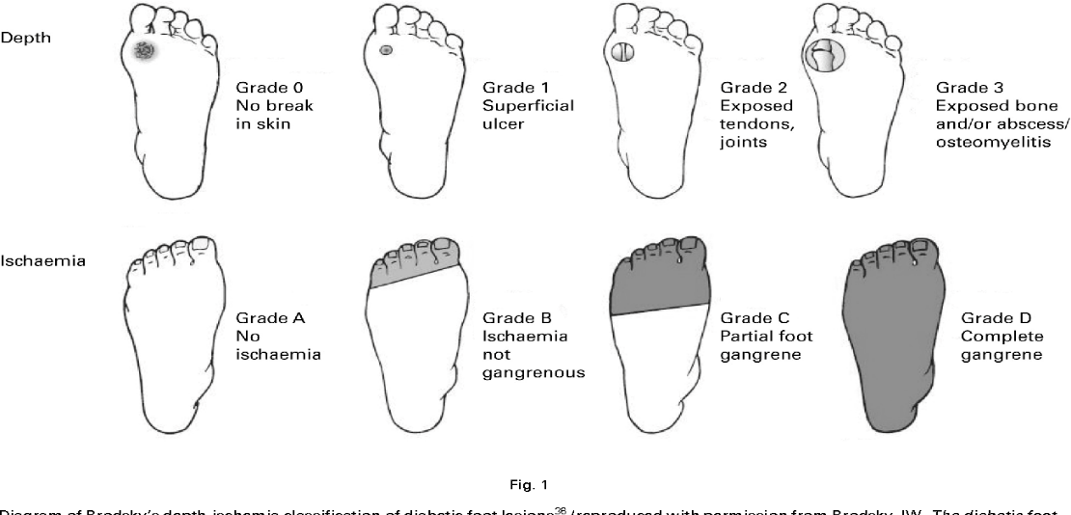

By presenting these proposals, we aim to revolutionize the field of diabetic foot ulcer (DFU) detection. The transition from binary to multi-class classification promises to provide healthcare professionals with a deeper understanding of DFUs, enabling more precise diagnosis and tailored treatment plans. This advancement holds the potential to enhance patient care, reduce complications, and improve the overall quality of life for individuals with diabetes. Furthermore, it contributes to the growing body of knowledge in medical image analysis, facilitating better DFU management practices and advancing the field of computer-aided diagnosis in healthcare.